System Requirements Specification
BROKERAGE FOR PROPERTIES

By G. Balamurugan
Marlensoft Private Limited

Table of Contents
Table of Contents ii
Revision History ii
- Introduction 1
  - Purpose 1
  - Product Scope 1
  - References 1
- System Overview 2
  - System Context 2
  - System Architecture 2
- Functional Requirements 3
  - Identity Management and Authorization 3
  - Search and Location Selection 3
  - Dynamic Filtering and Sorting 3
  - Property Listing and Details Page 4
  - Communication and Real Time Messaging 4
  - Property Posting Form 4
  - Database and Storage Architecture 4
- Non – Functional Requirements 5
  - Performance 5
  - Security 5
  - Availablity 5
  - Scalablity 5
  - Reliablity 5
  - Usablity 5
  - Compatablity 5
- System Requirements 6
  - Software Requirements 6
  - Hardware Requirements 6
  - Api Requirements 6
  - Database and Storage Requirements 6
- Database Design 7
  - User Table 7
  - Properties Table 7
  - Properties Images Table 8
  - Liked Properties Table 8
  - Messages Table 8
  - Notification Table 9

Introduction

Purpose

The purpose of this document is to define the software requirements for the Brokerage for Properties application. This platform is a scalable digital real estate marketplace designed to seamlessly connect property sellers with potential buyers and renters, powered by a robust ASP.NET Core and Web API architecture.

Product Scope
The Brokerage for Properties platform is a comprehensive web-based real estate solution that streamlines property discovery, listing, and communication. The core scope includes:
- Identity Management: Secure user registration and login utilizing JWT authentication and password hashing.
- Seller Portal: A guided, multi-step interface for owners to list properties (Buy, Rent, Plots), capturing location details, specifications, pricing, and high-quality images.
- Buyer Portal: An advanced, location-first search engine allowing targeted searches (by district and sub-area) with granular filtering (BHK, price range, property type, and construction status).
- User Dashboard: Centralized management for property postings, liked and contacted properties, and personalized search tracking for buyers seeking rental properties, plots, or full residential purchases.
- Direct Communication: Integrated messaging and direct call functionalities between buyers and sellers, supported by instant cross-user notifications.
- Admin Portal: A centralized administrative interface for moderating and verifying property listings, managing user accounts and role permissions, monitoring platform analytics, and maintaining overall system integrity.

References
The system's architecture, user flows, and feature sets are benchmarked against industry-leading real estate platforms to ensure optimal market standards:
- Housing.com: Referenced for intuitive location-based search, dynamic filtering criteria, and property listing UI.
- NoBroker.in: Referenced for direct buyer-to-seller communication models, subscription structures, and streamlined property on boarding workflow

System Overview

System Context

The Brokerage for Properties system operates as a centralized web-based intermediary platform connecting property buyers and sellers. Users access the application via a standard web browser, interacting with a frontend interface that communicates via RESTful HTTP requests to a secure ASP.NET Core Web API backend. The backend manages all business logic, user authentication, direct communication routing, and data persistence interacting with a relational database and media storage.

System Architecture
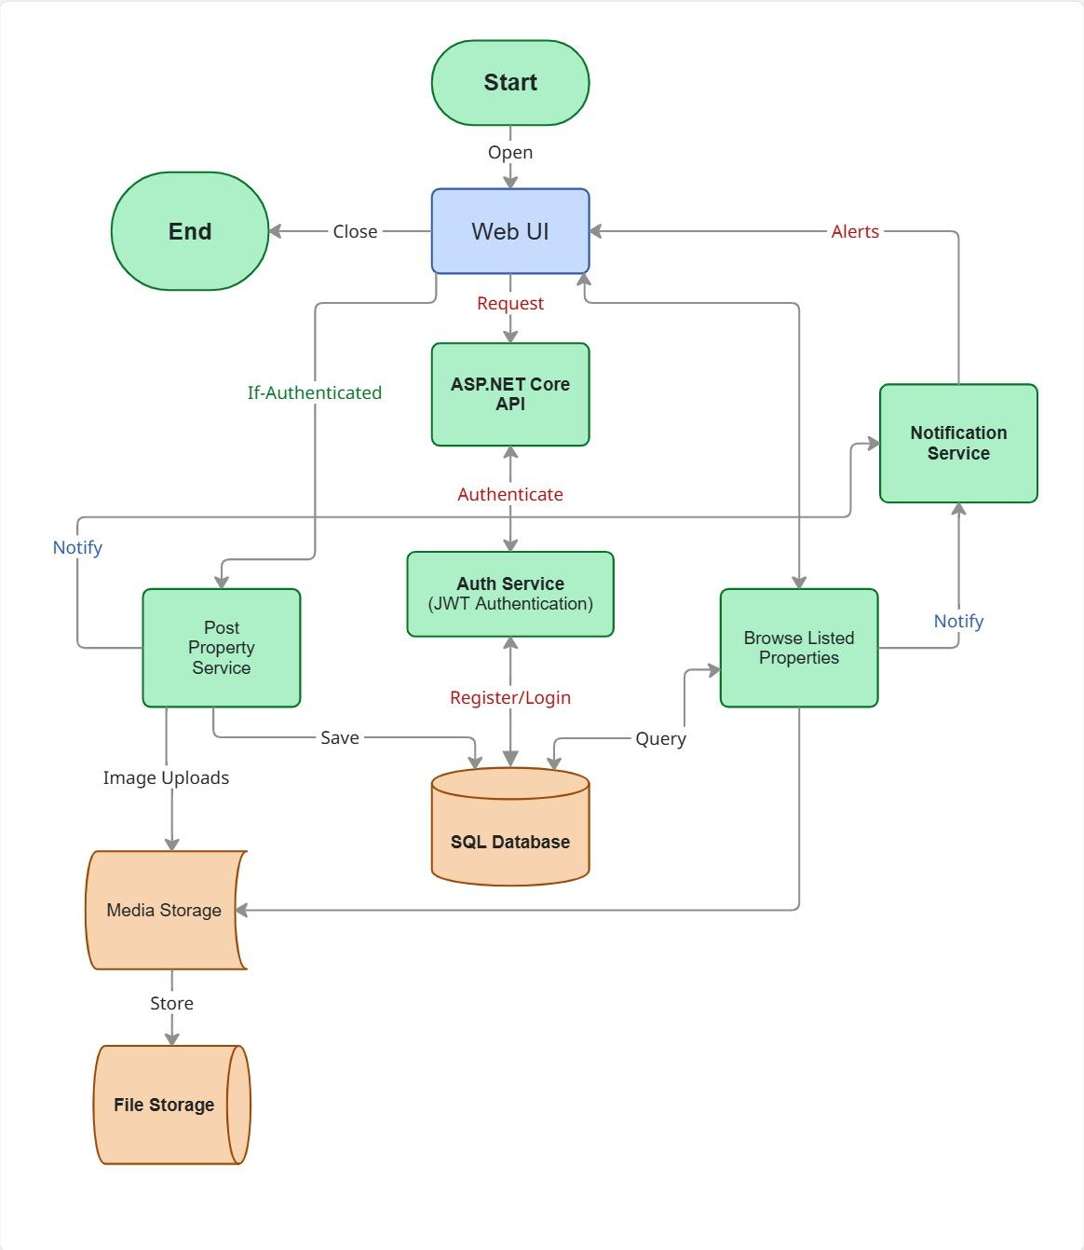

3. Functional Requirements
3.1 Identity Management & Authorization
- FR-1.1 User Registration: Enables new users to create accounts using full name, email address, mobile number, and password. By default, newly registered accounts are assigned the standard Customer role.
- FR-1.2 Credential Protection: Passwords must be hashed prior to database insertion using the bcrypt cryptographic algorithm with an adaptive cost factor. This ensures workload scalability and protects against high-speed brute-force attacks.
- FR-1.3 JWT Authentication: Upon valid credential verification, the system issues a signed JSON Web Token (JWT) containing encrypted user identity and role claims (Customer or Admin).
- FR-1.4 Restricted Access Controls:
  - Public Access: Unauthenticated users can browse public home pages, view search listings, and read blog content.
  - Authenticated Customer Authorization: Users possessing the Customer role can save/like properties, reveal seller contact details, send quick messages, and access the 3-step property submission wizard.
  - Authenticated Admin Authorization: Users possessing the Admin role gain exclusive access to moderation tools, property verification systems, platform analytics, and user account management features.
3.2 Search & Location Selection
- FR-2.1 Location Hierarchy: Provides a multi-tier location selector where selecting a primary District/City (e.g., Chennai) dynamically loads its specific localities (e.g., Adambakkam, Velachery).
- FR-2.2 Intent Categorization: Allows customers to isolate properties based on operational intent: Buy, Rent, or Plots.
3.3 Dynamic Filtering & Sorting
- FR-3.1 Granular Filter Engine: Executes real-time database queries based on the following criteria:
  - Property Type: Apartment, Individual House, Plot, Villa, Agricultural Land, Duplex.
  - BHK Configuration: 1BHK, 2BHK, 3BHK, 4BHK, 4BHK+.
  - Price Scale: Custom minimum and maximum price range boundaries (ranging from ₹0 to ₹1000 Cr).
  - Area Scale: Built-up square feet range.
  - Sale Type: New Booking, Resale.
  - Construction Status: Ready to Move, Under Construction.
  - Secondary Attributes: Admin-verified status, Property Age, Facing Direction, Furnishing Type.
- FR-3.2 Reset Filter: Clears all applied search parameters and restores default location listing results.
- FR-3.3 Dynamic Result Re-Ordering: Re-orders matching records by Relevance, Latest Listing, Price (Low to High), Price (High to Low), or Area Size (Sq Ft).
3.4 Property Listings & Detail Pages
- FR-4.1 Listing Feed: Renders total matching property counts and concise property cards featuring the primary image, title, price, key specs, like toggle, contact button, and an Admin Verified trust badge where applicable.
- FR-4.2 Dedicated Detail Page: Selecting a property card opens a comprehensive single-page route detailing full description, extended specs, interactive image gallery, location metadata, and seller contact triggers.
3.5 Communication & Real-Time Messaging
- FR-5.1 Contact Number Display: Selecting the "Contact Seller" option reveals the seller's verified contact phone number to authenticated buyers.
- FR-5.2 In-App Quick Messaging: Provides an inline messaging modal on the property detail page to send text inquiries directly to the listing owner.
- FR-5.3 Bidirectional Notification System:
  - Triggers an instant push/in-app notification to the seller upon receiving a buyer inquiry.
  - Triggers an instant push/in-app notification to the buyer when the seller replies to their query.
  - Sustains ongoing real-time chat threads accessible from each user's respective dashboard.
3.6 Property Posting Form (Customer Workflow)
- FR-6.1 Page 1 (General Data): Captures Property Type, Listing Type (Rent/Sell), and primary Mobile Number.
- FR-6.2 Page 2 (Property Specs): Captures Property Name, City, Society/Building Name, Locality, Built-up Area (Sq Ft), and Furnishing Status.
- FR-6.3 Page 3 (Pricing & Media): Captures Price/Monthly Rent, Security Deposit, Availability Date, and multi-file property image uploads. Upon submission, the property goes live immediately as an Unverified listing, making it accessible to buyers while queued for optional Admin verification.
- FR-6.4 Property Management & Listing Updates: Enables listing owners (Customers) to edit their active properties and Administrators to modify any platform listing. Users can update textual attributes (pricing, title, descriptions, specifications, availability date) and manage media assets (deleting existing images or uploading replacement files). Every modification automatically updates the listing's LastModifiedAt timestamp and LastModifiedByUserID reference while appending a detailed record to the
PropertyAuditLogs trail.

3.7 Database & Storage Architecture
- FR-7.1 Relational Data Storage: Persists all structured textual metadata (user profiles, property attributes, chat threads, transaction logs, and search indexes) in a relational database engine (MS SQL Server).
- FR-7.2 File System Media Storage: Stores raw uploaded image files securely in server directory storage, saving sanitized relative image URLs to the relational database records.

3.8 Administration & Governance
- FR-8.1 Property Verification & Moderation: Provides administrators with a moderation dashboard to review live listings, toggle an IsVerified trust badge for authentic properties, or flag/deactivate fraudulent and spam listings.
- FR-8.2 Platform Metrics Dashboard: Displays system-wide operational metrics, including total registered customers, total active listings, pending unverified properties, and total contact inquiries generated.
- FR-8.3 User & Content Management: Allows administrators to search registered customer accounts, inspect posted listing histories, and deactivate user accounts violating platform terms.

Non – Functional Requirements
4.1 Performance
Ensures property searches, dynamic filters, and posting pages respond within three seconds, even during peak browsing hours. Fast response times improve user satisfaction and property discovery efficiency.
4.2 Security
Protects buyer and seller accounts using HTTPS, password hashing, JWT authentication, and safeguards against SQL injection, XSS, and CSRF attacks to maintain platform trust and data privacy.
4.3 Availability
Requires the property portal to remain operational with minimal downtime, targeting 99.9% uptime so users can search, list, and contact sellers whenever needed.
4.4 Scalability
Enables the application to support an increasing volume of property listings, user accounts, and concurrent search queries without performance degradation as the platform grows.
4.5 Reliability
Ensures consistent operation, accurate property location indexing, and instant message delivery while preserving database integrity and dependable service.
4.6 Usability
Focuses on an intuitive interface that allows buyers to easily apply location filters and enables sellers to complete the 3-step property posting wizard with minimal learning effort.
4.7 Compatibility
Ensures the application functions correctly across different web browsers, desktop screens, mobile devices, and operating systems.

5. System Requirements
5.1 Software Requirements
- Frontend Technology: HTML5, CSS3, JavaScript to create responsive, interactive, and user-friendly interfaces that communicate with backend services.
- Backend Framework: ASP.NET Core Web API (.NET 10).
- Database Management System: Microsoft SQL Server.
- Micro-ORM Layer: Dapper.
- Authentication Security: JSON Web Token (JWT) bearer authentication with ASP.NET Core Identity.
- Development Environment: Visual Studio, Postman (API testing).
5.2 Hardware Requirements
- Application & Database Server:
  - Processor: Quad-Core 2.4 GHz or higher.
  - Memory: 8 GB RAM minimum (16 GB recommended).
  - Storage: 100 GB SSD (scalable based on media volume).
- Client Device:
  - Any standard smartphone, tablet, or desktop.
  - Web browser supporting modern JavaScript standards (Chrome, Edge, Firefox, Safari).
  - Stable internet connection (minimum 2 Mbps).
5.3 API Requirements
- Architecture Style: RESTful HTTP API over secure HTTPS endpoints.
- Payload Format: JSON for all data transfers.
- Header Security: Authorization: Bearer <JWT_TOKEN> header required for protected routes.
- Documentation & Testing: Swagger UI for auto-generated endpoint specifications.
5.4 Database & Storage Requirements
- Relational Storage: Database hosting normalized tables for User profiles, Property details, Locations, Subscriptions, and Chat logs.
- File Media Storage: Dedicated server directory storage or cloud file storage (e.g., Azure Blob Storage) to host uploaded property images, storing relative file URLs in database records.
- Indexing Engine: Primary and foreign key indexes configured on City, Locality, Property Type, BHK, and Price columns to ensure sub-second query performance.
6. Database Design

6.1 Roles Table The Roles table manages user permissions and authorization access levels across the platform (Customer, Admin, SuperAdmin). Fields:
- Role ID
- Role Name
- Description
- Created At
6.2 Users Table The Users table manages user identity, login credentials, and contact details. It supports role-based access for buyers, sellers, and administrators while securing account data. Fields:
- User ID
- User GUID
- Role ID
- Full Name
- Email Address
- Password Hash
- Mobile Number
- Is Active (Boolean - Default: True)
- Created At
6.3 Properties Table The Properties table stores all key information regarding real estate listings submitted by sellers. It captures general details, technical specs, locations, dynamic filtering tags, and pricing parameters. Fields:
- Property ID
- User ID (Seller / Owner)
- Property Name
- Category / Looking For (Rent / Sell / Plot)
- Property Type (Apartment, House, Plot, Villa, Agricultural Land, Duplex)
- City
- Locality / Area
- Building / Project / Society Name
- Built-up Area (Sq Ft)
- Furnish Type (Furnished, Semi-Furnished, Unfurnished)
- Price / Monthly Rent Amount
- Security Deposit
- Available From Date
- BHK Type (1BHK, 2BHK, 3BHK, 4BHK, 4BHK+)
- Sale Type (New Booking, Resale)
- Construction Status (Ready To Move, Under Construction)
- Property Age
- Facing Direction
- Is Verified (Boolean - Managed by Admin, Default: False)
- Is Active (Boolean - Managed by Admin to soft-delete/hide, Default: True)
- Created By User ID
- Created At
- Last Modified By User ID
- Last Modified At
6.4 Property Images Table The Property Images table maintains uploaded image references linked to specific properties. It allows listings to display multi-image galleries on the frontend. Fields:
- Image ID
- Property ID
- Image URL / File Path
- Is Primary Image
- Uploaded At
6.5 Liked Properties Table The Liked Properties table tracks properties saved or favorited by authenticated buyers for quick access on their dashboard. Fields:
- Liked ID
- User ID (Buyer)
- Property ID
- Saved At
6.6 Property Audit Logs Table The Property Audit Logs table records administrative changes, updates, and moderation history for every property listing on the platform. Fields:
- Audit Log ID
- Property ID
- Action Type (Create, Update, Verify, Delete, Deactivate)
- Modified By User ID
- User Role At Time
- Change Summary
- Modified At
6.7 Messages Table The Messages table records quick message interactions sent between buyers and sellers regarding specific property listings. Fields:
- Message ID
- Property ID
- Sender User ID
- Receiver User ID
- Message Content
- Sent At
- Is Read Status
6.8 Notifications Table The Notifications table logs real-time and push alerts generated for users when inquiry messages or account updates occur. Fields:
- Notification ID
- User ID
- Title / Alert Text
- Is Read Status
- Created At

